The Meeting At The Inn
For use with The Good Samaritan – Luke 10:25-37 | www.Jeanfurgal.org

It is one week later. The priest, the Levite and the Good Samaritan are on their return journeys. By chance, all are staying at the same inn and sharing a meal together at the same table. Usually Jews and Samaritans did not speak with each other, but sometimes things are different when people travel.

The innkeeper approaches and tells the Good Samaritan the injured man recovered and left after a few days. Now, the Samaritan owes more money for his care. While the priest and Levite watch with surprise, the Samaritan pays the injured man’s bill.

“I saw that man,” said the Levite, “but I could not stop. I had an appointment with a scribe in Jericho.”

“I saw him, too,” declared the priest. “He was lying beside the road, terribly bruised. Poor fellow! I thought about stopping to help him, but I was hurrying to Jericho to lead a worship service. I am so relieved you had the time to stop and help him.”

The Good Samaritan looked at them and threw up his hands. “Time! Time! Who has time? I was on my way to my son’s wedding. I arrived so late my family is still not speaking to me!”

The Levite was shocked. “How could you allow the troubles of a stranger to make you late for your son’s wedding?”

“That’s what my wife asked me. She thinks I am a fool! I still do not know who he was. I tried to pass by. But, when I heard him moan, I knew if I failed to help him that moan would haunt me for the rest of my life. What do you say? Am I a fool?”

The priest and Levite were so stunned by the question, they said nothing.
The Good Samaritan finished his meal and left the table. The priest and Levite exchanged shocked looks.

“What a strange fellow,” remarked the Levite. “I don’t blame his family for being angry. He is a fool. Just a stupid guy, like all the rest of the Samaritans.”

The priest looked down. “Maybe not” he mumbled. “Maybe not. That man showed compassion. We did not.”

Luke 10:25-37 New English Translation (NET Bible)

The Parable of the Good Samaritan

²⁵ Now an expert in religious law stood up to test Jesus, saying, “Teacher, what must I do to inherit eternal life?” ²⁶ He said to him, “What is written in the law? How do you understand it?” ²⁷ The expert answered, “Love the Lord your God with all your heart, with all your soul, with all your strength, and with all your mind, and love your neighbor as yourself.” ²⁸ Jesus said to him, “You have answered correctly; do this, and you will live.”

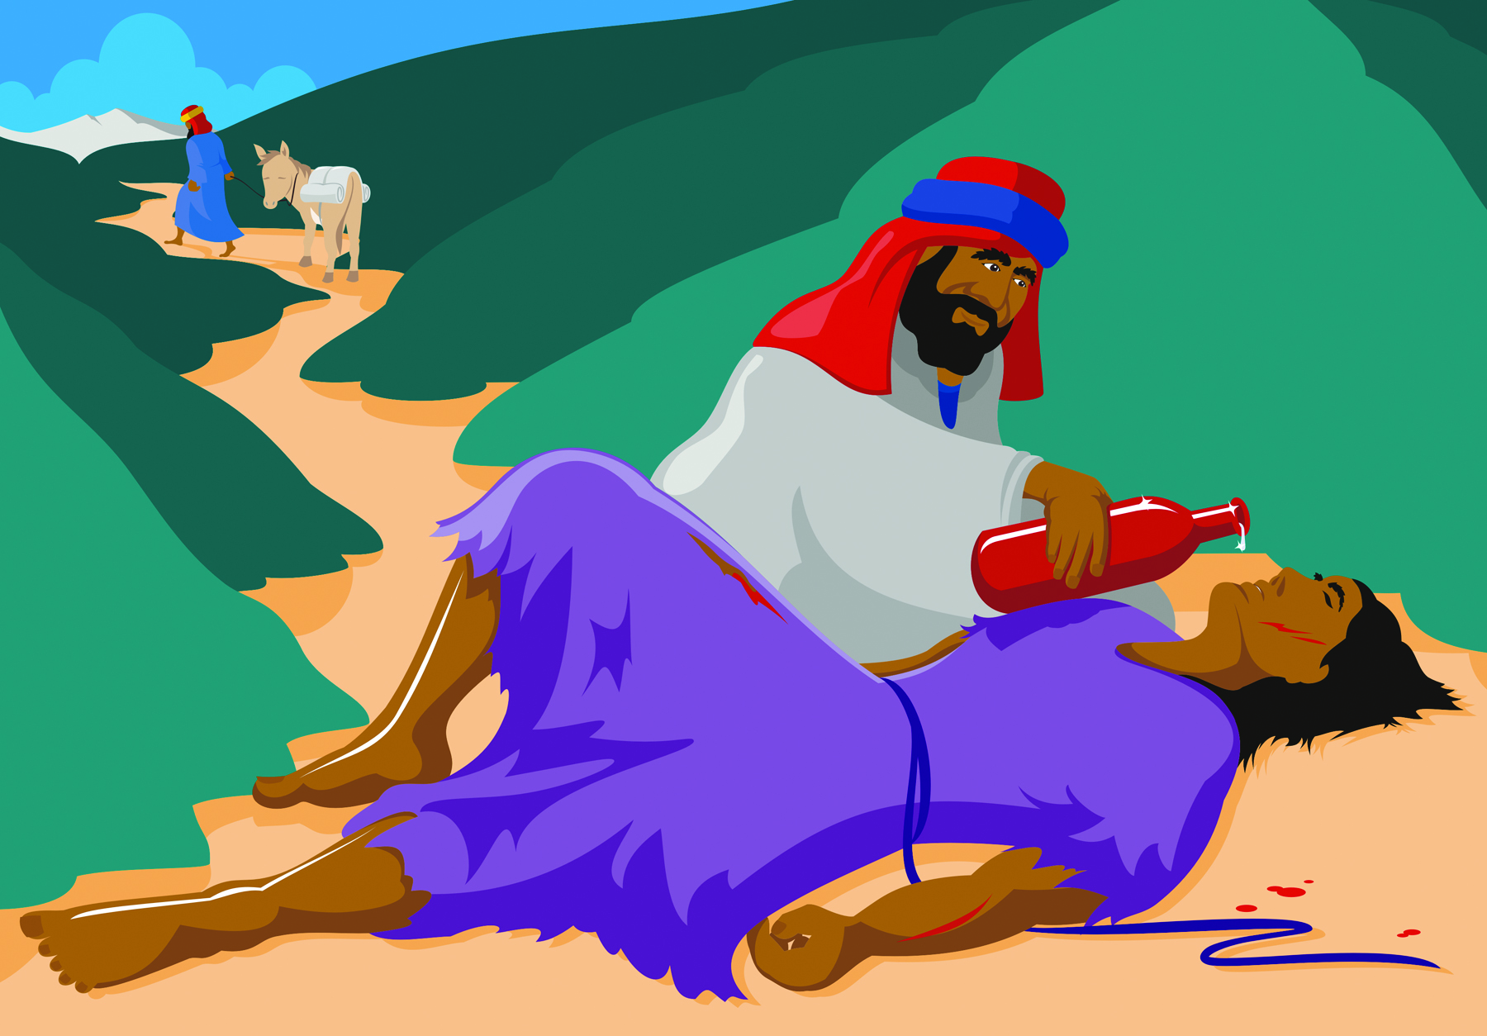
²⁹ But the expert, wanting to justify himself, said to Jesus, “And who is my neighbor?” ³⁰ Jesus replied, “A man was going down from Jerusalem to Jericho, and fell into the hands of robbers, who stripped him, beat him up, and went off, leaving him half dead. ³¹ Now by chance a priest was going down that road, but when he saw the injured man he passed by on the other side. ³² So too a Levite, when he came up to the place and saw him, passed by on the other side. ³³ But a Samaritan who was traveling came to where the injured man was, and when he saw him, he felt compassion for him. ³⁴ He went up to him and bandaged his wounds, pouring oil and wine on them. Then he put him on his own animal, brought him to an inn, and took care of him. ³⁵ The next day he took out two silver coins and gave them to the innkeeper, saying, ‘Take care of him, and whatever else you spend, I will repay you when I come back this way.’ ³⁶ Which of these three do you think became a neighbor to the man who fell into the hands of the robbers?” ³⁷ The expert in religious law said, “The one who showed mercy to him.” So Jesus said to him, “Go and do the same.”

NET Bible® copyright ©1996-2006 by Biblical Studies Press, L.L.C.

