How To Develop A Good Story
For Use with Storytelling: The Good Samaritan | www.Jeanfurgal.org

Some teachers are natural spinners of tales, but for those of us who need help to become a good storyteller, there is a basic formula to follow. Aim to make your story emotional. Strive to stimulate feelings, such as, comfort, fright, sorrow, excitement or inspiration.

• Present your story as a scene, or a series of scenes.

There are eight elements of a scene. All elements must be employed.
The Eight Elements Of A Scene

- Describe the place.
- Name the hero.
- Tag the hero (clothing, attitude, etc.)
- Start the action. Use dialog.
- Introduce a villain or an opposing force.
- Establish conflict. Use dialog.
- Resolve the conflict.
- Close the scene. How does the hero feel/what does the hero do?

When you make use of all eight elements, the story achieves its full impact because each element makes the story come alive in a different way. If you are “fixing” a dull story in your lesson plan, just add the missing elements. Use more exciting words. For example, instead of, “He said,” say, “He warned, he admitted, he boasted,” etc.

• Now let’s practice by creating a teaching story.

Suppose you are teaching a lesson on the importance of being a good neighbor, as described in the parable of The Good Samaritan. This was a major theme for Jesus. One way or another, most of His parables illustrated a different way of being a good neighbor in daily life in ancient Palestine. However, as a religion teacher today, you need a story that offers a 21st century example of being a Good Samaritan.
If you follow the steps in the above formula for powerful storytelling, you might compose a story something like the one below. Then, using the questions given, you can help your students apply the teaching of the parable to their daily lives.

• We will create a story about a hero named "Cowboy Jake."

1. Describe the place:

The valley is the setting. The scene is set in an outdoor place.

2. Name the hero:

Cowboy Jake looked across the valley, then ran to his horse. He jumped into the saddle and urged Ranger to a fast gallop. Jake is the hero. This is a fine western name.

3. Tag the hero with some identification:

Cowboy is the tag. This gives us a picture of a man wearing a big hat dressed in worn jeans and boots.

4. Start the action:

Jake ran to his horse is the action that makes the story start to move. The audience wonders what has alarmed Jake. It begins to care.

5. Introduce the villain or opposing force:

His neighbor’s three boys were racing through his herd of cattle, whooping and hollering. They were scattering the cattle in all directions. It would take his cowhands several hours to find all of them and restore peace. Anger surged through his whole body.

6. Describe the Conflict:

“What are you doing on my property, spooking my cattle?” Jake shouted.

Billy, the 12-year-old big brother, was the spokesman. “Oh, we weren’t hurting anything, Sheriff Jake. Just having some fun.”

Well my cattle aren’t having any fun. I’m going to call your daddy. I’m going to tell him to give you a good whipping and lock you in the barn for a week. Then, I’ll give him the vet bill for any broken legs my cattle have.”

“No, no, please,” Billy cried. “Don’t tell Paw. He’ll kill us.”

“Better yet, maybe I’ll just lock you up in jail. Then your daddy will have to deal with the judge.”

Billy smirked. “You can’t fool me, Mr. Jake. It isn’t a crime to chase a few old cows.”

Just then, Slim Jim, Jake’s cousin, galloped into the group. “Throw these runts in jail, Jake. They are terrorizing our cattle.”

Jake leaned forward and fixed his eyes on Billy. “Have you ever heard of Criminal Animal Abuse?”

Suddenly, Jake sat up. He had heard the sound of calves bleating. “Hear that? Follow me,” he commanded.

He led them around a stand of trees where they saw five very young, very frightened baby calves. They were crying for their moms. The largest was no more than two weeks old.

“See what I mean?” Slim Jim snarled. “Those little hellions are killing our stock.”

7 Resolve the Conflict. Use dialog:

Jake watched the boys grow somber as they viewed the consequences of their prank. He realized they weren’t bad kids. Just insensitive. His anger faded. It had never occurred to the boys that calves have feelings.

“Tell you what. Let’s make a deal. I won’t arrest you, and I won’t tell your daddy if you will take care of these young ones.

Relieved, Billy agreed.

Slim Jim snorted and galloped away.

Jake continued, “That means you will stay with them until their moms find them. You will take them into the shade and pet them and talk to them until they calm down. You will take turns fetching water for them. The pond is a half-mile east of here. It will be a few hours before we gather the herd and their mothers start searching.”

Directions delivered, Jake nudged Ranger.

“Wait. Wait,“ Billy called. “Ma’s expecting us home for lunch.

8 Finish the Action:

The most common scene endings either tell how the hero feels about the resolution or describes the consequences of it. I like to end my story with an action:

Jake thought for a moment. He looked down into Billy’s eyes and saw a worried young man trying to work his way out of a difficult situation. He took out his cellphone. “I’ll talk to your mother. ”

“And, next Saturday,” he continued, “if you like, you boys can ride out with me. The fences need to be inspected and there are three ponies in the barn that need some work.”

Billy's expression brightened. Jake smiled, turned Ranger, and trotted away.

Create powerful discussion questions.

The art of designing good discussion questions is essential for a religion teacher to master. Discussing the questions with your students is another teaching method that offers a religion teacher the opportunity to teach values. Through discussion, you can help your students see their daily, secular world through the eyes of faith.

To learn about the power of questions and how to use them, and for more information on teaching methods for religion teachers please visit Jeanfurgal.org.
Cowboy Jake, The Good Samaritan
For Use with Storytelling: The Good Samaritan | www.Jeanfurgal.org

Cowboy Jake looked across the valley then ran to his horse. He jumped into the saddle and urged Ranger to a fast gallop.

His neighbor’s three boys were racing through his herd of cattle, whooping and hollering. They were scattering the cattle in all directions. It would take his cowhands several hours to find all of them and restore peace. Anger surged through his whole body.

“What are you doing on my property, spooking my cattle?” Jake shouted.

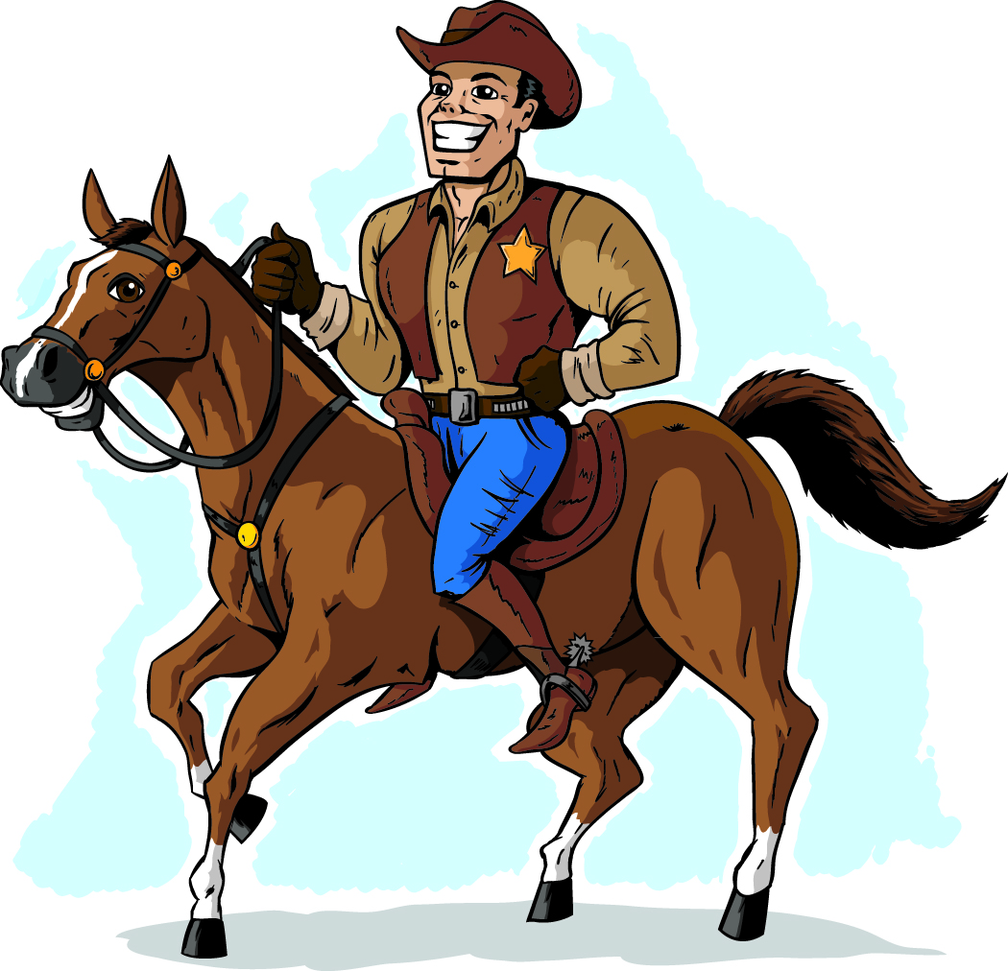

Billy, the 12-year-old big brother, was the spokesman. “Oh, we weren’t hurting anything, Sheriff Jake. Just having some fun.”

Well my cattle aren’t having any fun. I’m going to call your daddy. I’m going to tell him to give you a good whipping and lock you in the barn for a week. Then, I’ll give him the vet bill for any broken legs my cattle have.”

“No, no, please,” Billy cried. “Don’t tell Paw. He’ll kill us.”

“Better yet, maybe I’ll just lock you up in jail. Then your daddy will have to deal with the judge.”

Billy smirked. “You can’t fool me, Mr. Jake. It isn’t a crime to chase a few old cows.”

Just then, Slim Jim, Jake’s cousin, galloped into the group. “Throw these runts in jail, Jake. They are terrorizing our cattle.”

Jake leaned forward and fixed his eyes on Billy. “Have you ever heard of Criminal Animal Abuse?”

Suddenly, Jake sat up. He had heard the sound of calves bleating. “Hear that? Follow me,” he commanded.

He led them around a stand of trees where they saw five very young, very frightened baby calves. They were crying for their moms. The largest was no more than two weeks old.

“See what I mean,” Slim Jim snarled. “Those little hellions are killing our stock.”

Jake watched the boys grow somber as they viewed the consequences of their prank. He realized they weren’t bad kids. Just insensitive. His anger faded. It had never occurred to the boys that calves have feelings.

“Tell you what. Let’s make a deal. I won’t arrest you, and I won’t tell your daddy if you will take care of these young ones.

Relieved, Billy agreed.

Slim Jim snorted and galloped away.

Jake continued, “That means you will stay with them until their moms find them. You will take them into the shade and pet them and talk to them until they calm down. You will take turns fetching water for them. The pond is a half-mile east of here. It will be a few hours before we gather the herd and their mothers start searching.”

Directions delivered, Jake nudged Ranger.

“Wait. Wait,“ Billy called. “Ma’s expecting us to be home for lunch."

Jake thought for a moment. He looked down into Billy’s eyes and saw a worried young man trying to work his way out of a difficult situation. He took out his cellphone. “I’ll talk to your mother. ”

“And, next Saturday,” he continued, “If you like, you boys can ride out with me. The fences need to be inspected and there are three ponies in the barn that need some work.”

Billy's expression brightened. Jake smiled, nudged Ranger and trotted away.

