Teachers Workshop and Classroom Lesson Plan
Teaching Methods for Religion Teachers | www.jeanfurgal.org

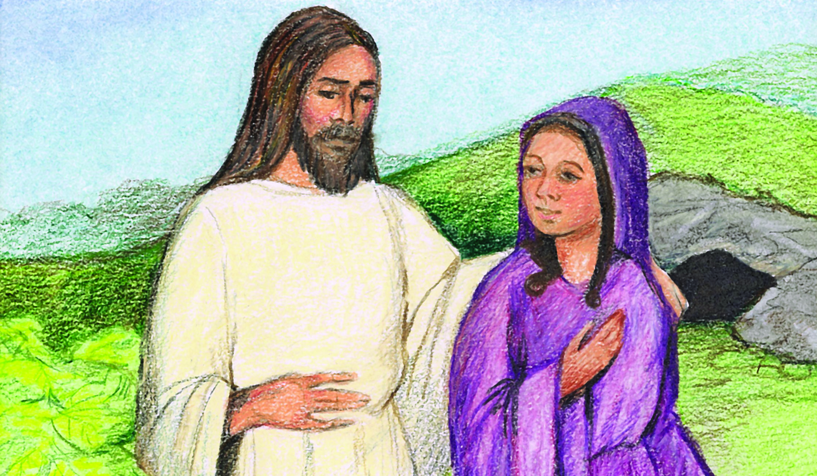

Part I • Teacher Trainer's Workshop

The Meditation Teaching Method

This teachers workshop shows how to effectively use the meditation teaching method in the classroom. When the Risen Christ appears to Mary Magdalene in the garden, she realizes that in some miraculous way He still lives. We will present a meditation video to help students feel Mary’s emotions so that they, too, may share in her joy. Identifying with Mary’s experience will strengthen the students’ faith at this time in history, when belief in the Resurrection is under fierce assault.

- - - - - - - - - - - - - - - - - - - - - - - - - - - - - - - - - - - - - - - - - -
Aim: To give the teacher-trainer acquire an understanding of the dynamics of meditation, and prepare teachers to use this teaching method effectively.

Prepare for the teachers meeting.
Workshop Materials

- Classroom Meditation Part II: Teaching The Resurrection lesson plan.
- Classroom Meditation Part III: Jesus Appears to Mary Magdalene.
- Parts I and II are included in this workshop kit. Please visit my website to download the classroom meditation video and other resources.
(visit www.JeanFurgal.org to download these materials)

The best way to prepare teachers to teach a lesson is to have them experience it pretty much as their own students will. The only difference is that, from time to time, you will ask them to stop and discuss methodology or a point of theology.

Start by discussing the less familiar teaching method, the meditation. Use the remaining time to review the presentation and meaning of the Resurrection appearances. You might begin by asking your teachers to describe their own experiences with meditation. Then, introduce the meditation by describing it.

Our meditation includes both music and art. A member of my congregation, who is a professional artist, created six beautiful drawings that illustrate the story of the risen Christ’s appearance to Mary Magdalene. While the scenes unfold, they are accompanied by Austin Miles’ hymn, In The Garden.
- - - - - - - - - - - - - - - - - - - - - - - - - - - - - - - - - - - - - - - - - -
Show the classroom meditation.

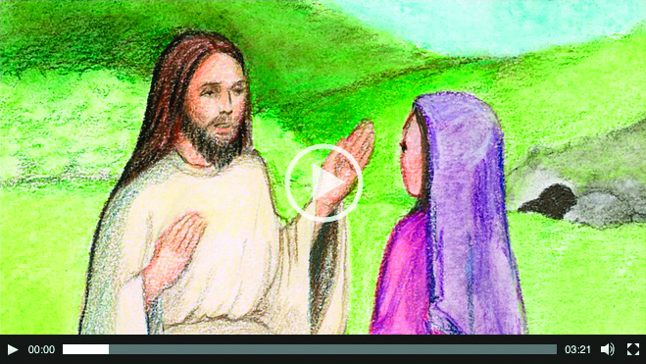
Show the video meditation, or create your own slide show
using the six illustrations and Austin Miles' hymn.

Discuss the psychology of meditation.

The meditation teaching method is not commonly used in the classroom. Thus we must prepare our student’s imaginations for this activity. During the first part of the lesson, they will focus on the text. Not only will they learn the basic facts of the Risen Christ’s appearance to Mary Magdalene, they will also see that this story comes from the Bible. This gives our meditation an air of importance.

Through a meditation we knock on three doors to our students’ brains: sight, sound, and emotion. This multi-sensory approach is key to good teaching.

Our students like pictures. Our students like music. And, they like to feel joy. An activity that combines all three gives them an especially pleasing learning experience. Through images that show Mary’s story, and a song that expresses her feelings, we will spirit our students back two thousand years to the garden outside Jesus’ tomb. Along with Mary, they will experience the moment when the Risen Christ first appears to her, and she realizes that something wonderful has happened. He lives!

How does a classroom meditation work?

I struggled to learn how to use this meditation. As I planned the lesson, I became more aware of the fact that it called for some tricky mood management in the classroom. I offer my journey to a solution with the hope that your teachers will learn more about mood management.

The problem I faced was in the transition from one mood to another. If I used the calm meditation immediately after the lively class discussion, I might change the mood too abruptly. This could easily leave the students feeling grumpy. Mood changes should be inviting, not difficult.

Brain Chemistry And Learning

Our brains respond to changes in our environment by creating the proper mood response for a given situation. Somewhere inside our brains there is a “driver,” who is a bit like the driver of an automobile. In this case, the driver controls the length of our brainwaves. And, different brainwave sizes create different moods.

The brain’s appropriate response to a busy classroom scene is to create short brainwaves called beta waves. These make us alert and ready to participate in whatever activity is going on. On the other hand, when we are in a situation that requires us to be quiet and receptive, the brain creates longer waves, called alpha waves. These ease us into a calm mood.

Moving students from one brainwave state to another should be done slowly. A fast transition from beta to alpha is extremely difficult to enact, because this transition requires time. It’s like falling asleep; the muscles need time to relax before the chemical reactions that create alpha can be completed.

As I searched for something that would prepare our students for a meditation, I recalled that Austin Miles, the composer of In the Garden, wrote a fascinating description of the way God inspired him to compose the hymn. I also knew that telling his mystical story, with its dreamy mood, would gently ease our students into alpha and make them ready for the meditation.

Austin Miles’ story appears in Part II, the classroom lesson plan, which follows this teachers workshop.

- - - - - - - - - - - - - - - - - - - - - - - - - - - - - - - - - - - - - - - - - -
Gathering Material

I chose In The Garden for two reasons. First, it is my favorite hymn. Second, it is easier to illustrate a hymn than to find music that fits a picture.

Even so, finding good artwork was difficult. I searched through a catalog of museum quality prints, but they all felt too heavy. Each painting was created by a master artist, and intended to be displayed by itself. The different styles used in the museum pieces made the scenes in the story of Christ’s appearance to Mary Magdalene feel disconnected.

Finally, I asked an artist in our congregation to illustrate the hymn. She created the drawings with pastels, and I liked them so much that they now hang in my dining room.
- - - - - - - - - - - - - - - - - - - - - - - - - - - - - - - - - - - - - - - - - -
Conclusion

The meditation teaching method educates the emotions. My teachers and I have used this meditation many times with students from fifth grade through adult. So far, it has always left our students feeling as if they had shared a wonderful experience with Mary Magdalene—and strengthened students’ beliefs in the Resurrection.

What else can a teacher ask for, other than that her students identify with a major biblical story?
Part II • Classroom Lesson Plan
Teaching The Resurrection
Teaching Methods for Religion Teachers | Jeanfurgal.org
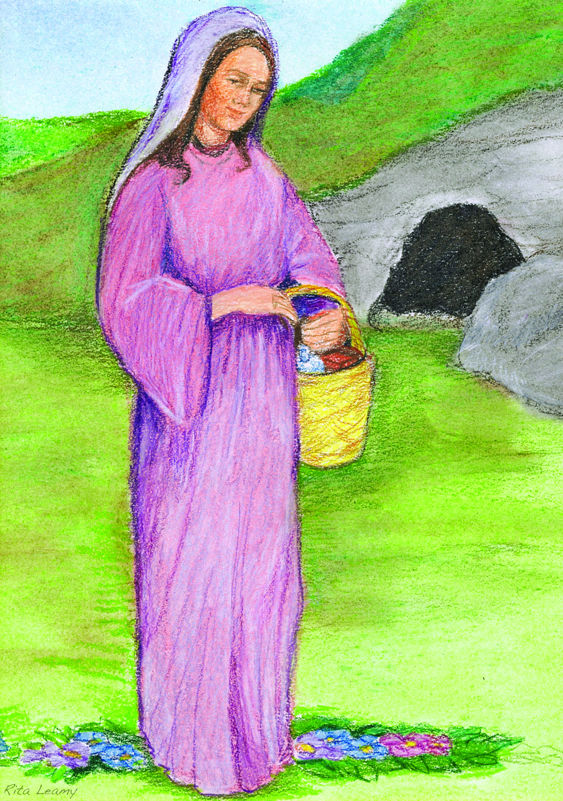
When we teach the Resurrection of Christ using eyewitness accounts and a classroom meditation, we create a powerful experience to help our students believe. This lesson plan presents the joyous moment at the tomb, when the Risen Christ first appears to Mary Magdalene. Also included are Bible stories, lecture material, and question sets. Striking illustrations and a large-screen video are set to the lyrics of Austin Mile’s popular hymn, In the Garden. (You may download these materials for free at www.jeanfurgal.org)

- - - - - - - - - - - - - - - - - - - - - - - - - - - - - - - - - - - - - - - - - -

Aim: To strengthen your students’ beliefs in the
Resurrection of Christ through lecture, Bible study,
and a classroom meditation.

Directions & Materials

- Distribute Bibles along with the list of Bible verses (key verses are listed in the last section).
- Page markers or Post-its. Assign each of the Bible texts you will use to a different student reader. Ask each reader to mark his/her page.
- Large-screen video meditation: Jesus Appears to Mary Magdalene. Please visit www.jeanfurgal.org to download the HD video and other resources.
- - - - - - - - - - - - - - - - - - - - - - - - - - - - - - - - - - - - - - - - - -
Teacher’s Introductory Questions

- In your opinion, what is the most important event in the history of the world? (Most Christians believe the Resurrection of Jesus Christ is the most important event in history. We will learn why during the course of this lesson.)
- Define the word, “Resurrection.” (After He died, Jesus rose to a new kind of life. But Christ’s risen body was much more than a revived corpse. For want of a better term, Paul called it a “spiritual body.” See 1 Cor. 15:44)
- What do you know about the meaning of the Resurrection of Christ? How does it affect our lives today?

- - - - - - - - - - - - - - - - - - - - - - - - - - - - - - - - - - - - - - - - - -
Transition to the lecture.

During today’s lesson, we will learn the rest of the story of the Resurrection of Christ, and what it means. When we are finished, I will ask you what you think is the most important teaching of this event.

Present the Bible story of the Resurrection of Christ.
(John 20:11-18)

Today we are going to follow the amazing events that happened after Jesus was buried in a cave.

Following the crucifixion, the disciples were terrified. Because they had participated in Jesus’ attack on Rome’s money changers at the temple, they feared the Roman authorities might arrest and crucify them. So they scattered and hid in different homes.
Meanwhile, early Sunday morning, Mary Magdalene went to Jesus’ tomb. She had intended to anoint His body, but when she arrived Mary found the guards missing, the stone rolled away, and Jesus’ body gone. She ran to tell Peter. He and John raced to the tomb, then saw for themselves that it was empty. After they left, Mary stood alone outside the tomb, weeping.

Reading 1:
Christ Appears To Mary Magdalene
John 20:11-18
(Ask the designated students to read their Bible references aloud.)

Soon the Risen Christ appeared to others. After Mary had left the garden, He joined two disciples as they fled to Emmaus. That same evening He appeared to ten of the disciples hiding in an upper room. But Thomas was missing. So, one week later when Thomas was with them, Christ appeared to the disciples again. We can hardly imagine the degree of excitement they felt!

When His disciples realized that Christ was alive, they burst out of their hiding places and hurried to the temple. There they proclaimed the good news to the crowds: “Christ has risen from the dead!”

Of course the Apostles’ preaching was not good news for the Roman and Jewish authorities. They feared people might believe the Apostles and think that Jesus was a god. If that happened, Christ’s authority would be greater than their own. So it was urgent that this claim be quickly discredited.

Immediately, attacks began against the belief that “Christ has risen.” They continue to this day. Central to these attacks is the guards’ report that the disciples stole Jesus’ body.
Reading 2:
The Guard's Report
Matthew 28:11-15

Why do you suppose the chief priests told the guards to lie?

This explanation for the empty tomb is highly unlikely. After the Crucifixion, in a state of shock, the disciples feared for their lives. So it is difficult to believe that the terrified disciples had the courage to steal the body. That crime was punishable by death.

Reading 3:
Frightened Disciples
John 20:19

(Call attention to the phrases, “behind locked doors,” and “for fear of the Jews.”)

What were the disciples so afraid of?

Of course the frightened disciples would not choose to further provoke the authorities by violating Jesus’ tomb.

Most amazing, within twelve hours of their discovery of the empty tomb, the Apostles’ behavior changed dramatically. These broken, desolate men, who were hiding and shivering in fear, suddenly became vibrant leaders filled with energy and courage. They were ready to go to the ends of the earth and risk their lives in order to proclaim the good news that Jesus Christ had risen from the dead.

This radical change in the Apostles’ behavior tells us that some incredible event had occurred. Certainly this change was not caused by something so mundane as stealing a corpse. Although people may continue to debate what happened, whatever it was, the event was extraordinary.

Today, reputable Scripture scholars believe that the Apostles’ new courage was inspired by their belief in the Resurrection of Christ. Each evangelist ends his gospel with descriptions of several post Resurrection appearances. During these encounters, Jesus reveals His Father’s message. In fact, the Risen Christ appears to the Apostles a number of times over a forty-day period. It is therefore reasonable for us to believe that the Lord’s appearances are what inspired the Apostles’ amazing transformation.

Reading 4:
Christ Is True God And True Man
John 14:8-11,20
John 10:30
Colossians 2:9

For Christians, the belief that Christ is True God and True Man is basic dogma. Although the teaching is present in these three Bible verses, the Nicene Creed states it most clearly.

Human words fail to express the exact nature of Christ’s risen body. It is a mystery. We only know that it was a new life form that was both material and spiritual. Some gospels show Him eating real food. In others, Christ walks through walls. For lack of a better term, St. Paul calls Christ’s risen body a “spiritual body.”

Reading 5:
Transformed By Christ
2 Corinthians 5:17
1 John 5:12-16
John 14:20

Give an example of a time your faith caused you to do something good?
When we receive Christ into our lives, usually at baptism, our human personalities are transformed by God’s love. A share of the risen life of Christ now lives within us. When we actively nurture it, we defeat our self-centered natures and become the best persons we can be.

Reading 6:
The Gift Of Eternal Life
John 3:16
John 11:25, 26

How do you imagine life after death? When we die, we will join Christ in heaven and be happy forever. This is one of Jesus’ most exciting revelations. When Christians look forward to heaven, the fear of death fades. Until Jesus revealed this message, most people thought that the dead slept forever in a dark, gloomy place.

- - - - - - - - - - - - - - - - - - - - - - - - - - - - - - - - - - - - - - - - - -
Teaching The Resurrection Classroom Meditation

In a few minutes, we will watch and listen as Mary Magdalene describes her meeting with the Risen Christ through a special hymn composed by Austin Miles. It’s “special” because of the mystical way the song was given to him. What follows is Mile’s account of his experience.
The Composer's Story
“One day in April 1912, I was seated in the darkroom where I kept my photographic equipment. I drew my Bible toward me and opened it to my favorite chapter, John 20. It was as though I was in a trance. As I read it that day, I seemed to be part of the scene. I became a silent witness to that dramatic moment in Mary’s life when she knelt before her risen Lord and cried, ‘Rabboni.’

“I rested my hands on the open Bible as I stared at the light blue wall. The light faded and I seemed to be standing at the entrance of a (dimly lit) garden, looking down a gently winding path shaded by olive branches. A woman in white with head bowed, hand clasping her throat as if to choke back her sobs, walked slowly out of the shadows. It was Mary Magdalene. When she reached the tomb, she bent over to look in and then ran away.

“Soon, John, in a flowing robe, appeared and looked into the tomb. Then came Peter, who entered the tomb followed slowly by John. As they departed, Mary reappeared and leaned her head upon the tomb and wept. Turning, she saw Christ standing there. So did I. She knelt before Him with arms outstretched, and looking into His face cried, ‘Rabboni.’

“I awakened in sunlight, gripping my Bible with my muscles tense and nerves vibrating. Under the inspiration of the Holy Spirit. I wrote as quickly as the words could be formed. The lyrics were exactly as they are sung today. That same evening I wrote the tune. It is sung today as it was written in 1912.”

Show the classroom meditation.

Show the video meditation, or create your own slide show
using the six illustrations and Austin Miles' hymn.
- - - - - - - - - - - - - - - - - - - - - - - - - - - - - - - - - - - - - - - - - -
Conclusion

Did the Resurrection really happen?

No one actually witnessed the resurrection of Christ. That took place inside the tomb. As a result, each of us must make our choice. Do we believe the unanimous testimony of the Apostles? Or, do we believe in the tale told by the Roman guards?

The Resurrection is our most important belief, because it creates a new possibility for our lives. As each of us opens ourselves more fully to the flow of Christ’s love, we become better lovers.

Gradually, as more and more people open themselves to Christ the world will fill with His love. Human culture will be ruled by peace, justice, and joy. A good hymn to express this teaching is Pass It On by Kurt Kaiser.

- - - - - - - - - - - - - - - - - - - - - - - - - - - - - - - - - - - - - - - - - -
Important Bible Verses
Jesus Appears To Mary Magdalene. John 20:11-18
The Guards’ Report Matthew 28:11-15
The Frightened Disciples John 20:19
Christ Is True God And True Man John 14:8-11,20; John 10:30; Colossians 2:9

Visit www.jeanfurgal.org for more exciting teaching methods,
lesson plans, workshops, and commentary!

